SIMATS ENGINEERING (SAVEETHA SCHOOL OF ENGINEERING)
Department of Computer Science and Engineering
CO3 ASSESSMENT TOOL 1 – Git & Docker Technical Assignment

Course Code: | CSA10 / CSA1063 | Course Title: | Software Engineering
CO Assessed: | CO3 | Assessment: | Assessment Tool 1 – Git & Docker Technical Assignment
Weightage: | 20% | Total Marks: | 25
CO3 Statement: | Build full-stack applications with an emphasis on containerization, version control, and collaborative development
Student Name: | P ROHINI | Reg. No.: | 192524147
Date: | 11-08-2026 | Duration: | 60 minutes

Code of Conduct
I P ROHINI (192524147) (Name / Reg No) certify that this submission is my original work and that I have adhered to the guidelines specified for this assessment. I understand that any violation of academic integrity rules will result in disciplinary action.
Signature of the Student: P ROHINI
Annexure A – Git & Docker Technical Assignment
Instructions to Students:
Each student has been assigned an individual problem statement. Based on the assigned problem statement, prepare a Git & Docker Technical Assignment by applying version control and containerization concepts. Your report should include appropriate diagrams, screenshots, commands, and explanations wherever applicable.

Assignment Questions
- Problem Analysis
  - Explain the assigned problem statement and identify the project objectives, functional requirements, and expected outcomes.
- Project Structure Design
  - Design and explain the folder structure of your project repository.
  - Justify the purpose of each major folder and file included in the repository.
- Git Repository Initialization
  - Create a Git repository for the project.
  - Explain the steps involved in repository initialization and describe the purpose of the essential Git files.
- Git Branching Strategy
  - Design a suitable branching strategy (e.g., Main, Development, Feature, Release, Hotfix).
  - Justify why the selected branching model is appropriate for the assigned project.
- Version Control Workflow
  - Demonstrate the Git workflow by performing meaningful commits, branch creation, merging, conflict resolution (if applicable), and repository synchronization.
  - Explain the purpose of each Git operation performed.
- Commit History Analysis
  - Present the commit history of the project.
  - Explain how commit messages follow good version control practices and contribute to project maintenance.
- Docker Environment Design
  - Explain why Docker is suitable for the assigned project.
  - Identify the application components that require containerization.
- Dockerfile Development
  - Design and explain the Dockerfile required to containerize the application.
  - Describe the purpose of each instruction used in the Dockerfile.
- Docker Compose Design
  - Develop a Docker Compose configuration for the project.
  - Explain the services, networking, volumes, environment variables, and dependencies used.
- Container Deployment and Testing
  - Demonstrate the execution of the application using Docker containers.
  - Explain the testing procedure and provide evidence that the application runs successfully.
- Benefits of Git and Docker
  - Discuss how Git and Docker improve collaboration, version management, portability, deployment, scalability, and maintainability for your assigned project.
- Challenges and Improvements
  - Identify the challenges encountered during implementation.
  - Suggest possible improvements and future enhancements for the Git workflow and Docker deployment.

Expected Deliverables
- Technical report (10 pages)
- Git repository with complete commit history
- Source code of the assigned project
- Dockerfile
- Docker Compose file (docker-compose.yml)
- Screenshots of Git operations and Docker execution
- Architecture and workflow diagrams

Rubrics for Calculation
Evaluation Criteria | Excellent (4 Marks) | Good (3 Marks) | Satisfactory (2 Marks) | Needs Improvement (1 Mark)
Problem Analysis & Project Design(20%) | Clearly explains the problem statement, objectives, requirements, expected outcomes, and well-organized project structure with proper justification. | Good analysis and project structure with minor omissions. | Basic analysis and repository structure with limited justification. | Incomplete or unclear analysis and project organization.
Git Repository & Branching Strategy(20%) | Repository initialized correctly with appropriate branching strategy, clear workflow, and proper repository organization. | Repository and branching strategy are mostly correct. | Basic Git setup with limited branching implementation. | Incorrect or incomplete Git repository and branching strategy.
Version Control Workflow & Commit History(10%) | Demonstrates meaningful commits, branching, merging, synchronization, conflict resolution, and professional commit messages with clear history. | Most Git operations demonstrated correctly with good commit history. | Limited Git workflow and commit practices. | Poor workflow and inadequate commit history.
Docker Implementation(20%) | Well-designed Docker environment, Dockerfile, and Docker Compose configuration with clear explanation of services, networking, volumes, and dependencies. | Functional Docker implementation with minor issues. | Basic Docker implementation with limited explanation. | Incomplete or incorrect Docker implementation.
Deployment, Testing & Results(15%) | Application successfully deployed and tested with appropriate screenshots and evidence of successful execution. | Deployment completed with minor issues. | Partial deployment and testing demonstrated. | Deployment unsuccessful or insufficient evidence.
Documentation, Challenges & Future Enhancements(15%) | Professional report (10–15 pages) with diagrams, screenshots, references, discussion of benefits, challenges, and future improvements. | Good documentation with minor omissions. | Basic documentation with limited discussion. | Poor documentation and insufficient analysis.

Criteria | Mark
System Requirement Analysis (30%) | /5
Selection of Software Architecture (25%) | /5
Architecture Diagram and Component Design (20%) | /5
Component Interaction and Quality Attribute Analysis (15%) | /5
Architectural Justification and Technical Presentation (10%) | /5
TOTAL | /25

CO3-ASSISSMENT TOOL-1

COURSE CODE: CSA1007
COURSE NAME: SOFTWARE ENGINEERING
NAME: P ROHINI
REG NO: 192524147

35) Smart Urban Traffic Congestion Prediction and Signal Optimization Platform
Industry Context
The transportation sector is rapidly adopting digital technologies to improve efficiency, safety, scalability, and decision making. Traditional approaches often rely on manual processes and reactive monitoring, resulting in delays, increased operational costs, resource wastage, and reduced service quality. There is a growing need for an intelligent, cloud-enabled, distributed platform capable of collecting real-time IoT and enterprise data, analyzing operational conditions, predicting risks, and supporting timely interventions.
Problem Statement
Design and develop a distributed Smart Urban Traffic Congestion Prediction and Signal Optimization Platform that continuously acquires real-time operational data from connected devices, enterprise systems, and users. The platform should detect abnormal events, generate predictive insights using AI/ML, notify stakeholders in real time, provide centralized dashboards, generate reports, and support secure, scalable, fault-tolerant operation across multiple locations.

Objectives
• Collect real-time operational data.
• Monitor system performance continuously.
• Detect anomalies automatically.
• Predict failures or risks using analytics.
• Notify stakeholders immediately.
• Generate dashboards and reports.

Git & Docker Technical Assignment
Title
Smart Urban Traffic Congestion Prediction and Signal Optimization Platform
1. Problem Analysis
Problem Statement
The proposed platform collects real-time traffic data from IoT devices, connected systems, and users. It analyzes the data to detect abnormal traffic conditions, predict congestion, support signal optimization, and provide alerts, dashboards, and reports.
Objectives
- Collect real-time traffic data.
- Monitor traffic continuously.
- Detect abnormal conditions.
- Predict traffic congestion.
- Optimize traffic signals.
- Send real-time alerts.
- Generate dashboards and reports.
- Provide secure and scalable operation.
Expected Outcomes
- Reduced traffic congestion and delays.
- Faster decision-making.
- Better resource utilization.
- Improved service reliability.
- Support for multiple locations.

2. Project Structure Design
Smart-Traffic-Platform/
│
├── frontend/
├── backend/
├── ml-model/
├── database/
├── tests/
├── Dockerfile
├── docker-compose.yml
├── .gitignore
└── README.md

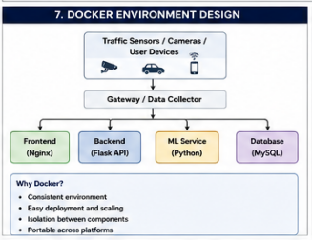

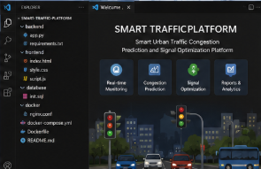

3. Git Repository Initialization

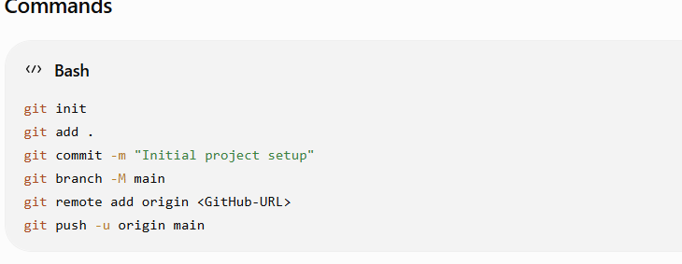

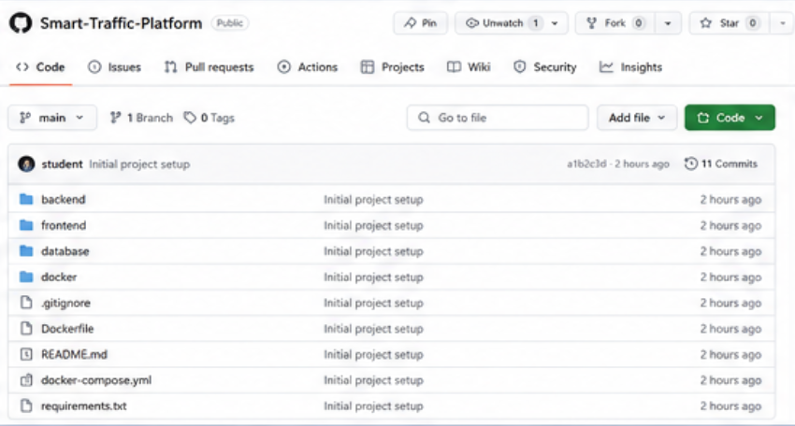

4. Git Branching Strategy
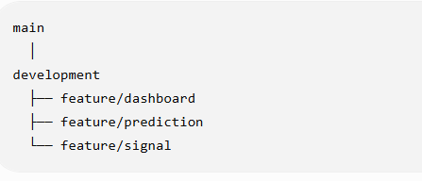
- main – Stable version.
- development – Testing and integration.
- feature – Individual feature development.
This makes development organized and reduces conflicts.
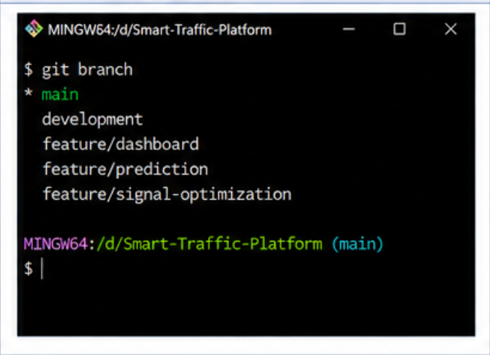
5. Version Control Workflow
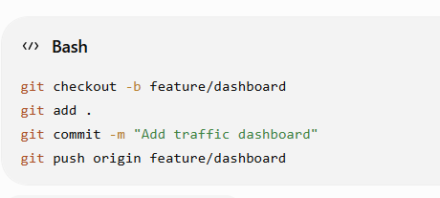
6. Commit History
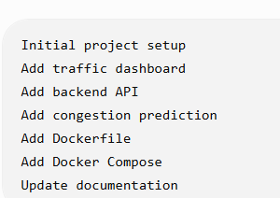
7. Dockerfile
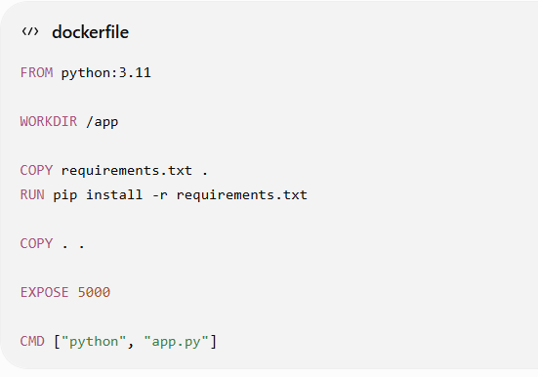
8. Benefits
Git
- Version control.
- Collaboration.
- Branching.
- Change tracking.
Docker
- Portability.
- Easy deployment.
- Isolation.
- Scalability.
- Maintainability.
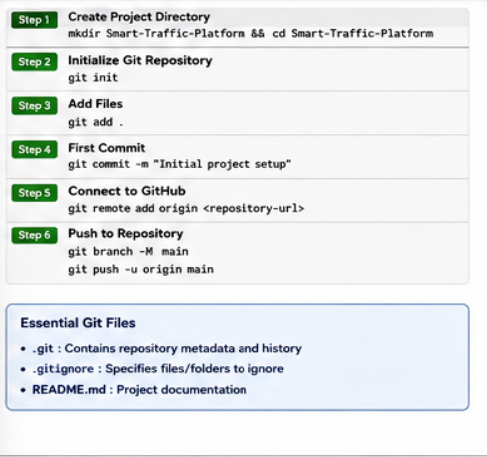
9. Deployment and Testing
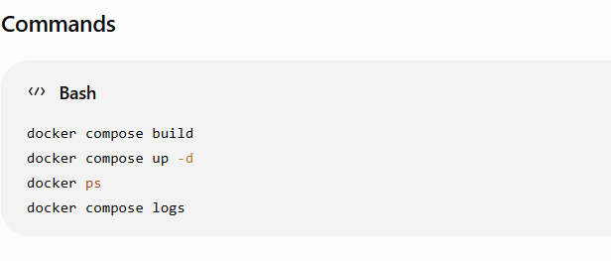
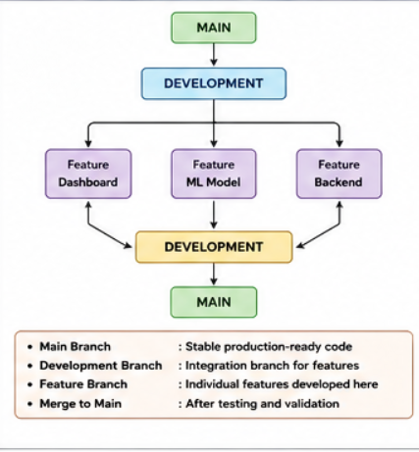

Testing
Check whether:
- Website opens.
- Backend works.
- Database connects.
- Traffic data is displayed.
- Dashboard works.
- Containers communicate correctly.

12. Challenges and Future Improvements

Challenges
- Handling real-time traffic data.
- Managing multiple services.
- Git merge conflicts.
- Docker configuration.
- Supporting multiple locations.
Future Improvements
- IoT integration.
- Advanced AI/ML prediction.
- Automatic signal control.
- Cloud deployment.
- Mobile application.
- Real-time notifications.

Conclusion
The Smart Urban Traffic Platform uses Git for version control and Docker for containerized deployment. The system helps monitor traffic, predict congestion, optimize signals, and support faster decision-making.

OUTPUT:
